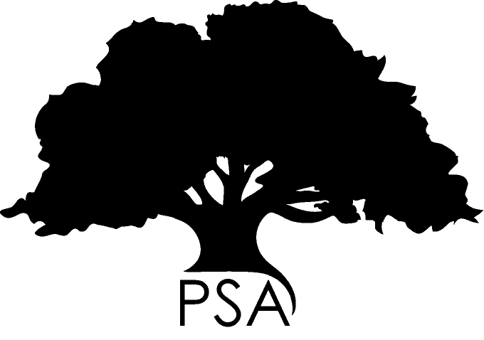**PSA**

**Fieldwork/Data**

**Collection Award**

The Postgraduate Students’ Association (PSA) represents all postgraduate students at the University of Western Australia and is a department of the Student Guild. The PSA exists to provide support for postgraduate students and improve postgraduate life.

**PSA Fieldwork/Data Collection Award**

The PSA Fieldwork/Data Collection Award is provided to assist students travelling to undertake fieldwork or data collection, which is necessary for their postgraduate degree. The PSA provides up to two awards in each round, valued at up to $900. The PSA reserves the right not to distribute all of the awards.

**Fieldwork/Data Collection**

UWA’s definition of fieldwork is as follows: “rural field work is defined as any approved practical work carried out by staff, students or volunteers for the purpose of teaching and/or research in places more than five kilometres outside urban areas which are not under University control but where the University is responsible for the safety of its staff, students and volunteers and others exposed to their activities.” Applications for this funding should normally fall under this definition.

Notice of intended fieldwork should be included in the Program of Study and Annual Reports submitted to the Graduate Research School. The intended activities must be in accordance with the rules and guidelines laid out in the UWA Fieldwork Procedures Rural and Remote (<http://www.safety.uwa.edu.au/topics/off-campus/field-work-remote>). Funding can be applied for retrospectively.

**ELIGIBILITY**

* Any student who is also a member of staff at UWA and/or any other University with appointments of 0.5 fraction or greater is not eligible for a PSA Fieldwork/Data Collection Award unless clear evidence is provided that the research degree is being undertaken in an entirely different department/budget unit from any staff appointment.
* Any student who is eligible for a staff travel grant scheme at UWA and/or any other University is not eligible for a PSA Fieldwork/Data Collection Award.
* Postgraduate students who are in receipt of other travel funding including a University Graduate Research School Travel Award may also apply for a PSA Fieldwork/Data Collection Award to supplement this funding although they must clearly demonstrate that this additional funding is required. Preference will be given to those students who have demonstrated that no other available funding is available to them.
* An applicant's research proposal must be approved by the Board of the Postgraduate Research School prior to approval of a PSA Fieldwork/Data Collection Award.
* Candidates enrolled as UWA postgraduates in Australia and overseas are eligible. A student who has taken intermission from candidature may be declared ineligible – for example if the student is occupied full-time with activities other than research for the degree.
* Full-time and part-time postgraduate research degree candidates are eligible.
* The PSA Fieldwork/Data Collection Award is intended to help offset the costs of fieldwork or data collection being undertaken within rural Western Australia, however, eligible applicants may apply for funding for similar activities within other areas. Preference will be given to those traveling within Western Australia with evidence of no other funding.

**Limitations on candidature length**

At the date of the research:

Full-time students in the first six months of enrolment in a Masters or Doctoral program are not eligible to apply; full-time students who have been enrolled in a Masters program for more two years, or Doctoral students enrolled for more than four years will not be eligible.

Part-time students in the first 12 months of enrolment in a Masters or Doctoral program are not eligible to apply; and part-time students who have been enrolled in a Masters for more than four years, or a Doctoral program for more than seven years, will not be eligible.

Applicants who were unsuccessful in the previous round may apply in the current and future rounds.

**Insurance Cover**

Consult the University's Travel Insurance Policy:

<http://www.safety.uwa.edu.au/policies/travel>

You will need to take additional insurance where any period of overseas leave is not related to your degree program.

**TERMS AND CONDITIONS**

If successful in their application, payment of funds will be conditional on recipients signing an agreement that they will:

* Write a 300-word report to be published in the PSA’s postgraduate magazine, *Postscript*, and on the PSA website.
* Provide receipts to the PSA to the value of the award, within 2 weeks of the return date nominated on the application form.

**CHECKLIST FOR APPLICATION**

Have you provided?

* An address which is operative until six weeks after the closing date
* Confirmation of enrolment
* Evidence of approval for your fieldwork
* An up to 500-word statement outlining the importance of this fieldwork/data collection to your research. The personal statement should be comprehensible and written in terms that demonstrate an awareness of the audience considering the application and the PSA awarding body.
* A clear, accurate and itemized budget indicating required resources and costs, expected additional expenses, and exactly how the PSA Award will be used. Do include a statement of other funding sources you will be using for the proposed journey. Please indicate if you will be self-funding. Please indicate if you will be self-funding.

**HOW THE AWARDS ARE JUDGED**

1. On the quality of your statement (i.e. its comprehensibility, demonstration of an awareness of the audience considering the application and the PSA awarding body, and the emphasis on the importance of the proposed fieldwork to your research).
2. Evidence of financial need.

*Please visit the PSA website for information on ways the PSA can help you!*

[*www.psa.guild.uwa.edu.au*](http://www.psa.uwa.edu.au/)